**Title:** Task 6 — Create a Strong Password and Evaluate Its Strength.

* **Internship Project:** Cybersecurity Internship (**ELEVATE LABS)**
* **Name:** Meet Pandit
* **Date:** 30/09/2025

**1. Objective**

The objective of this task is to understand the key characteristics of a strong password and to evaluate the effectiveness of different passwords using online strength-checking tools such as **PasswordMeter.com**. The goal is to identify weaknesses in common passwords and demonstrate how stronger passwords can be created.

## ****2. Tools Used****

* **Tool:** [PasswordMeter.com](https://passwordmeter.com?utm_source=chatgpt.com) (free online password strength checker)
* **Platform:** Web browser (Chrome)

## ****3. Procedure (Step-by-Step)****

1. Open the password strength checker at [passwordmeter.com](https://passwordmeter.com?utm_source=chatgpt.com).

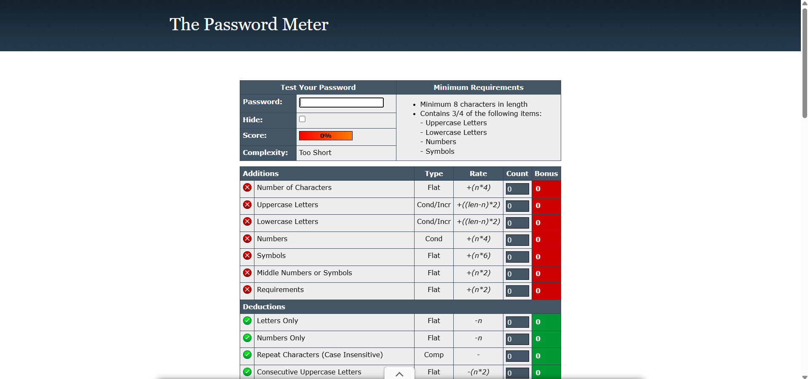

1. Enter a **weak password** (e.g., password) and note down the score and complexity result.

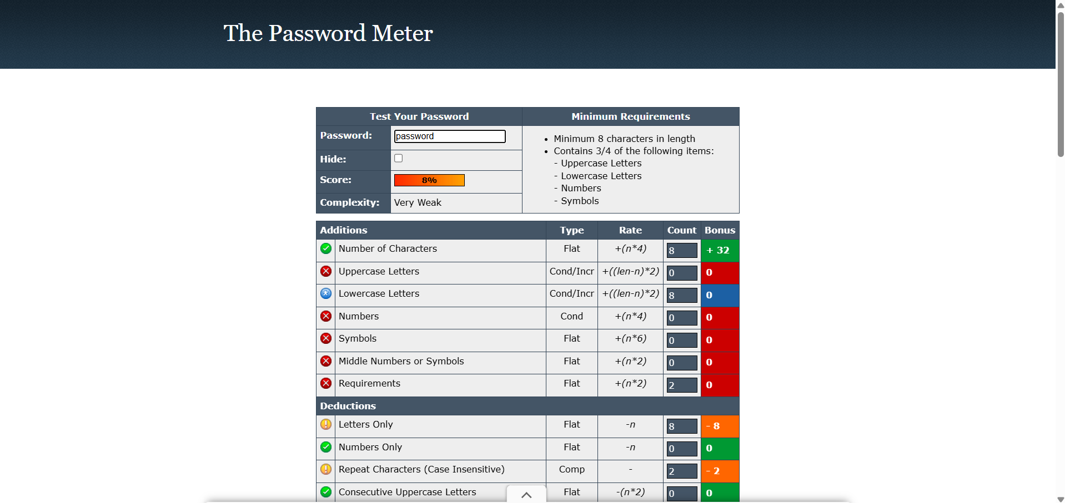

3. Enter a **medium-strength password** (e.g., Password@) and capture the results.

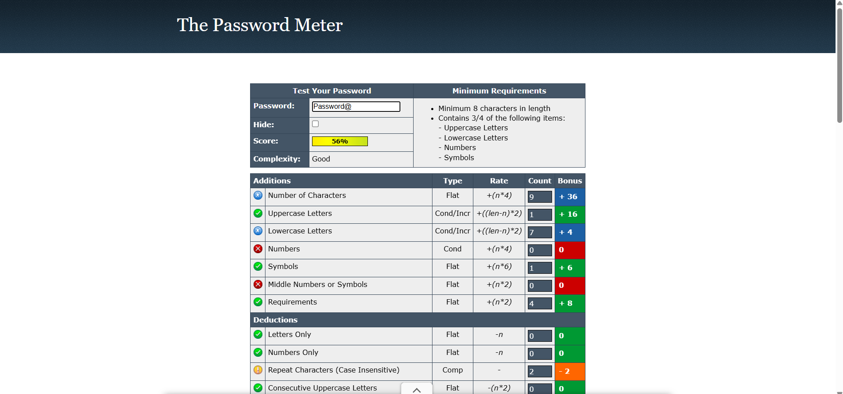

4. Enter a **strong password** (e.g., MyS3cureP@ssw0rd2025!) and observe how the score improves.

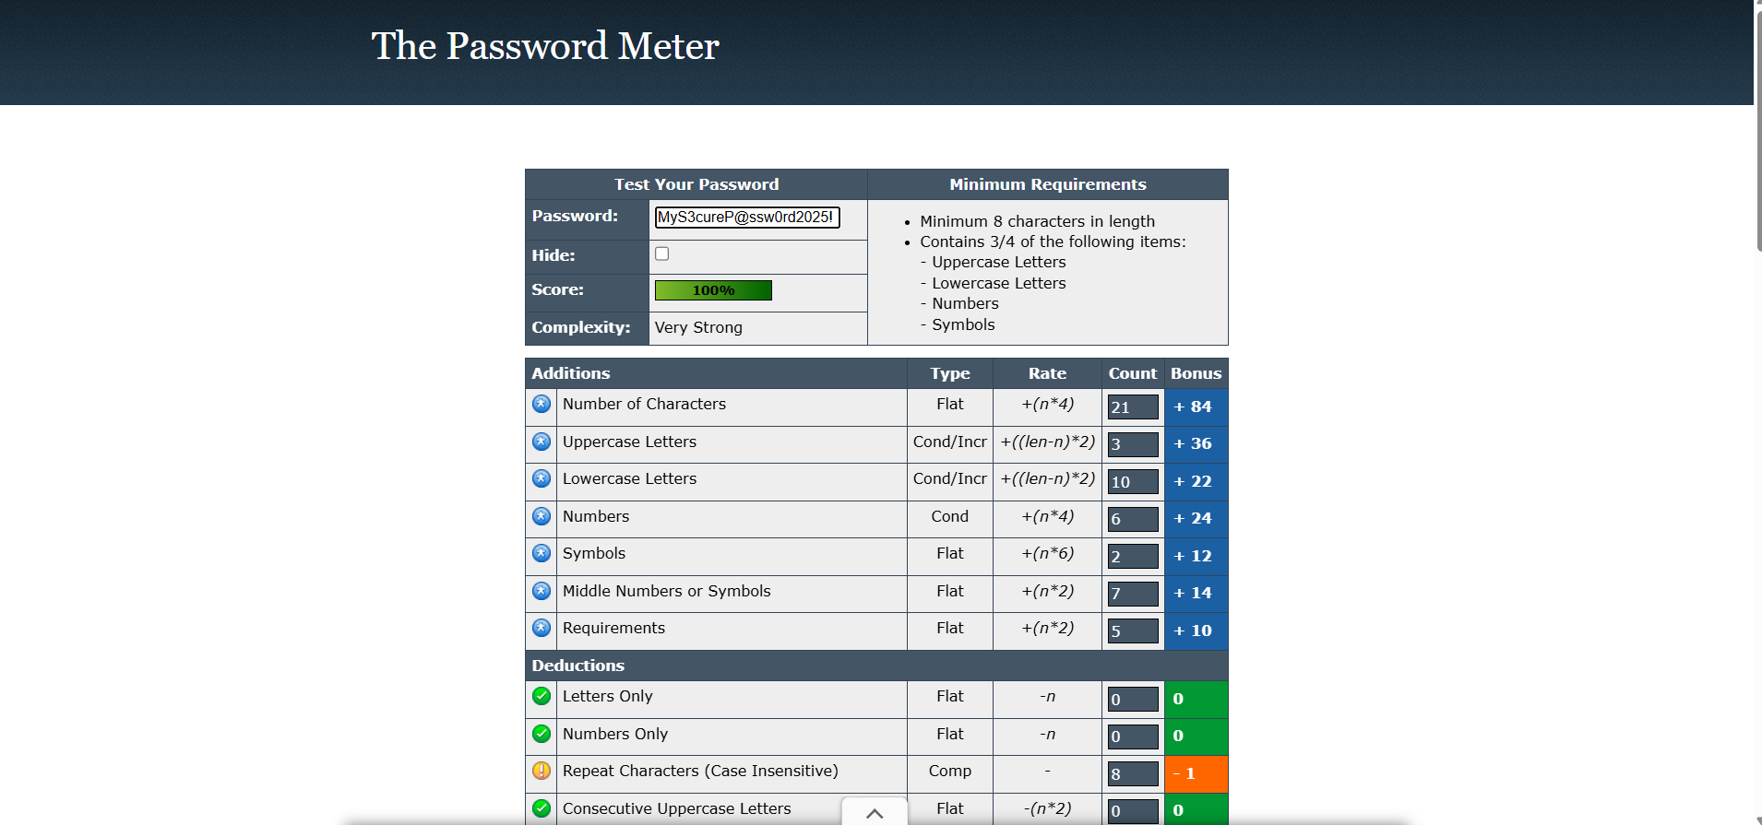

## ****4. Analysis****

* Passwords that are short, dictionary-based, or predictable scored **low**.
* Adding **symbols, numbers, uppercase/lowercase letters**, and increasing **length** raised the score significantly.
* PasswordMeter gave **bonuses** for variety and length, and **deductions** for sequences or letters-only strings.
* This confirms industry best practices (NIST, OWASP): length + complexity together make passwords stronger.

## ****5. Conclusion****

* This practical demonstrated that a strong password is one that is long, contains a mix of character types, and avoids common words or predictable patterns. Tools like PasswordMeter.com are useful for training and testing password quality, but in practice, users should also rely on **password managers** and enable **multi-factor authentication (MFA)** for maximum security.